The Big ‘at home’ Baking competition

Challenge one: Create six Insect or bug themed biscuits

You can add icing, chocolate, buttercream, sweets, nuts anything you wish as long as they are edible.

Be as creative as possible - these images are just an example of what you could your chosen biscuits could turn into!
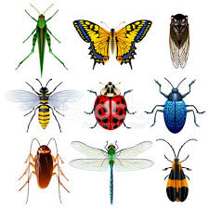

Post photographs of your winning entries via email or on Instagram by Friday 15 May to be in with a chance to win a £20 amazon voucher.
Entries to (ekstpartnership@gmail.com or @EastKentSchoolsTogether)
Winner announced 22 May.

You can use any recipe to make your biscuits but if you cannot get hold of flour you could try the recipe below:

Coconut macaroons

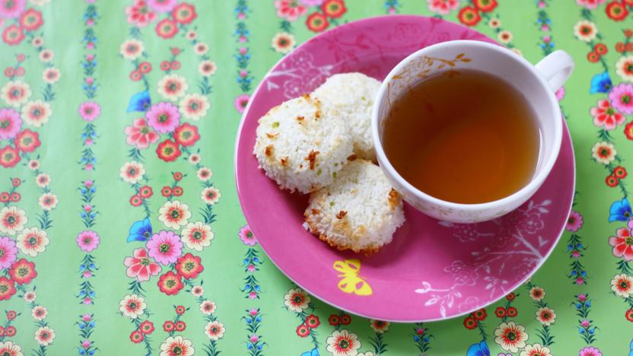
These coconut macaroons are gluten-free and very tasty. They're easy to make and a delicious way to use up leftover egg whites.
Preparation time less than 30 mins Serves Makes 12
- Ingredients:
2 egg whites ,100g caster sugar, 160g desiccated coconut, 1 tsp grated lime zest 1 tbsp lime juice (orange or lemon can be used as an alternative.)

Method
- Preheat the oven to 180C/160C Fan/Gas 4.
- Use your hands to mulch the egg whites, sugar, coconut, lime zest and juice in a bowl until they lightly come together.
- With wet hands, press the mixture into a flat, square shape about 1cm high.
- Use a small cylindrical shape to cut out small rounds, and place on a lightly oiled or nonstick baking tray.
- Bake for 12-15 minutes in the centre of the oven until very lightly golden, just touched with colour.
- Cool the macaroons on a wire rack, and store in an airtight jar.

