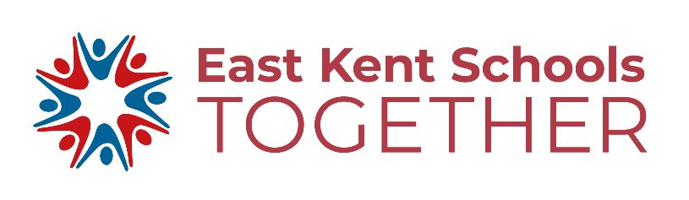 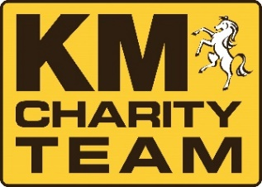

**CALLING ALL YEAR 9 & 10 STUDENTS**

**IT IS BAKE OFF TIME**

Your school is part of the East Kent School Together (EKST) partnership.

The KM Charity Team and EKST are holding a baking competition to raise money for Young Minds (EKST’s student charity) & The KM Charity Team’s literacy and road safety work

The first heat will take place in your school the week of 25 June 2018

The regional final will take place in September and you can compete to become the Champion!

**Sign up today to take part in this fun event.**

 



Choose one item to bake that reflects the theme of **summer**

Use a maximum of **10 ingredients**

Make sure you can make, bake and present it within the **1 ½ hour time limit**

sign up by 20 June at

**www.kmcharityteam.co.uk/busters-bake-off/**

Secure a minimum of £1 sponsorship

GET BAKING & Good Luck